**Experiment-8**

Create a simple cloud software application for Payroll Processing System using any Cloud Service Provider to demonstrate SaaS include the necessary fields such as Name of the employee, experience in present org , over all experience, basic pay, HRA, DA, TA, net pay, gross pay etc.

**Implementation:**

**STEP 01:**

Open a  Zoho web application and click a Create a New application and Create a New Component And select a Component Type as Form Type.

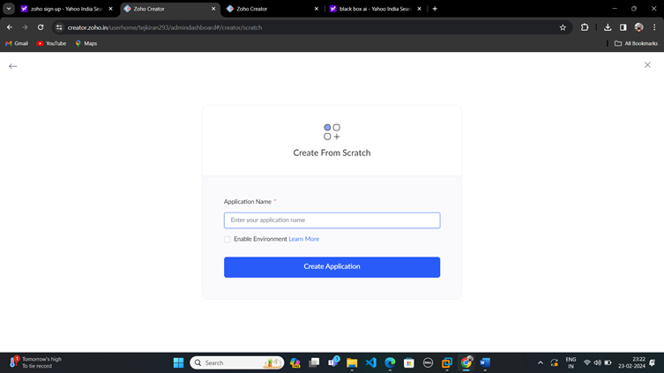

**STEP:02**

Start To a Create a Form from Scratch

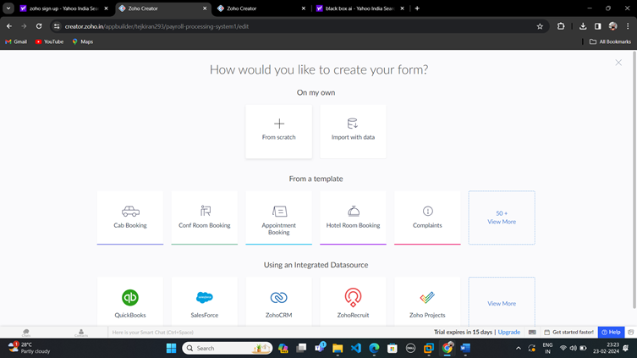

**STEP 03:**

To Give a Name For Your Form and click a Button Create From Scratch

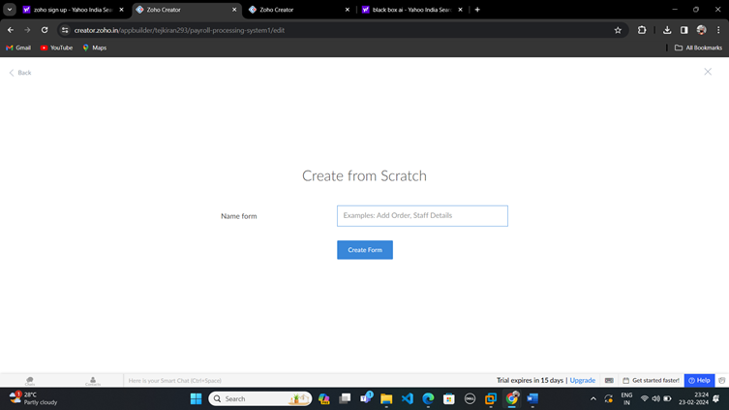

**Step-04:**

Create Log in form and edit the form.

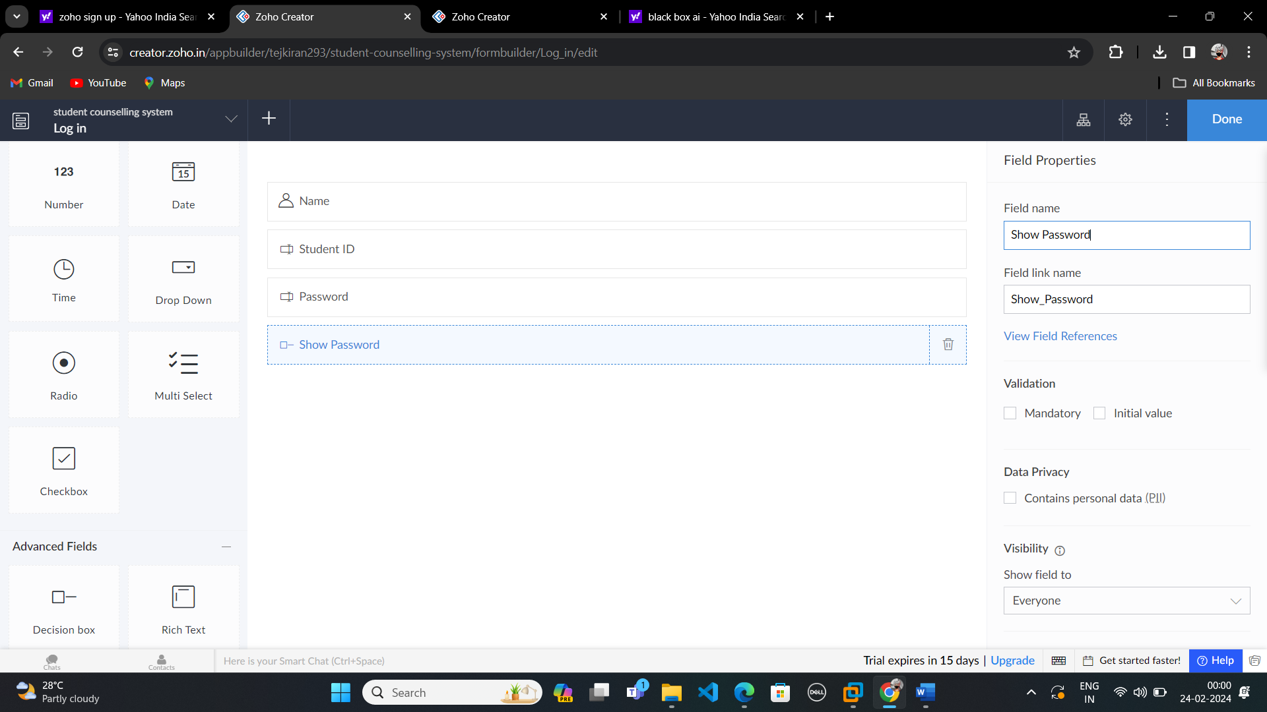

**Step-05:**

After that create another form and name it as Student Details.

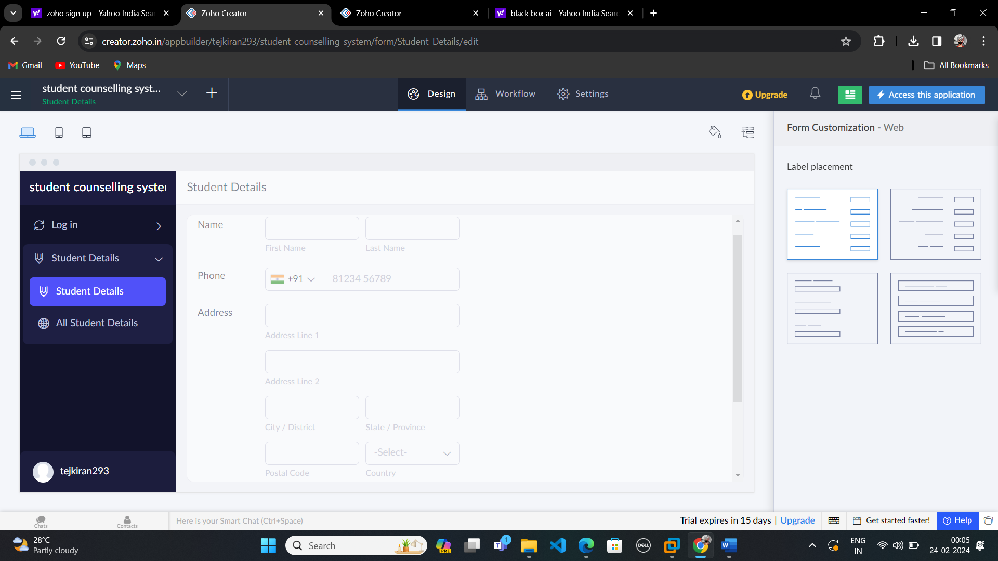

**STtep-06:**

Create another form and name it as Booking.

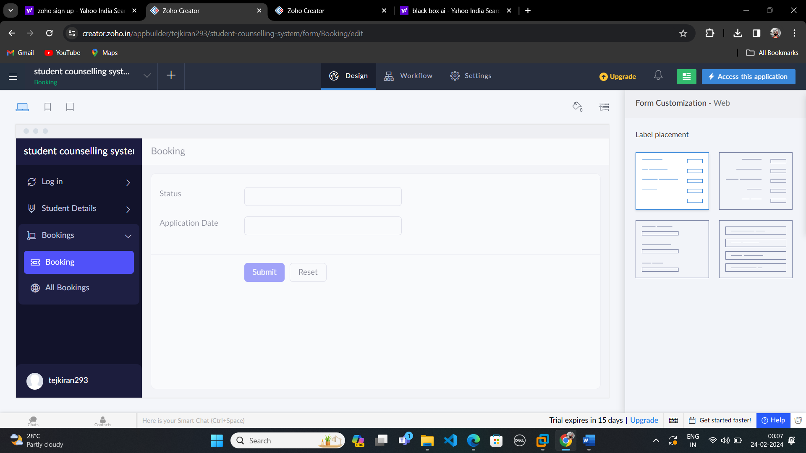

**Step-07:**

After that create another form and name it as Log out.

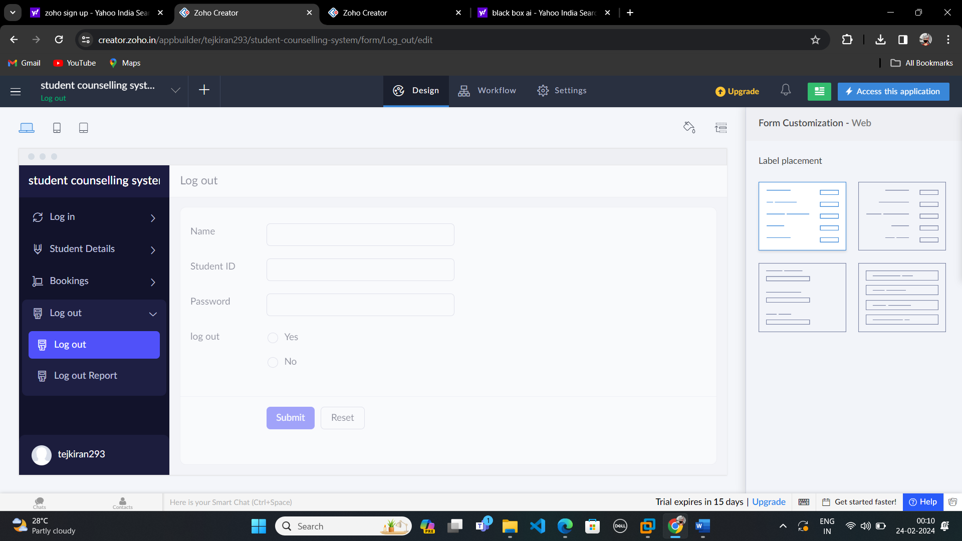

**Step-08:**

After creating report form tap Access this Application.

